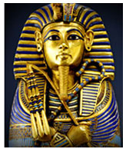
Ancient Egypt
A civilization of ancient northeast Africa- The great pyramids, pharaoh rulers, mummification, the great Nile river, coffins, societies and cities. Used incredible production techniques, created monumental artwork, established mathematics within society, used writing through hieroglyphics.

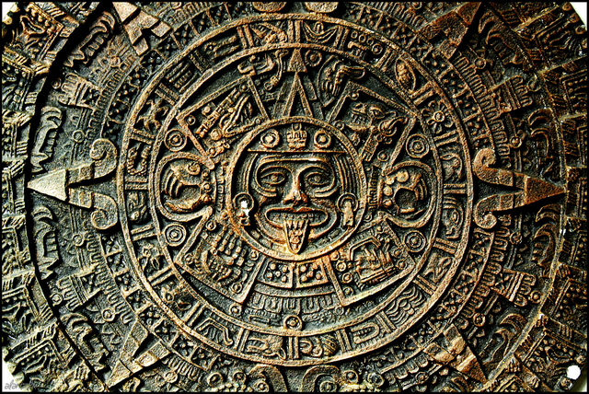
Pre-Columbian Era
Incorporates all prehistory before the appearance of significant European influences on the American continents, spanning the time of the original settlement in the Upper Paleolithic period to European colonization. Many pre-Columbian civilizations established hallmarks which included permanent settlements, cities, agriculture, civic and monumental architecture, major earthenware, and complex societal hierarchies.

Historic Tribe Regions include:

-Northeastern Woodlands Anishinaabe (Anishinape, Anicinape, Neshnabé, Nishnaabe)
Ojibwa (Chippewa, Ojibwe), Ontario, Michigan, Minnesota, and Wisconsin
-Southeastern Woodlands, Great Plains, Great Basin, Northwest Plateau, Northwest Coast, Southwest

-Maya civilization

-Teotihuacan civilization

-Olmec civilization

-Aztec/Mexica/Triple Alliance civilization

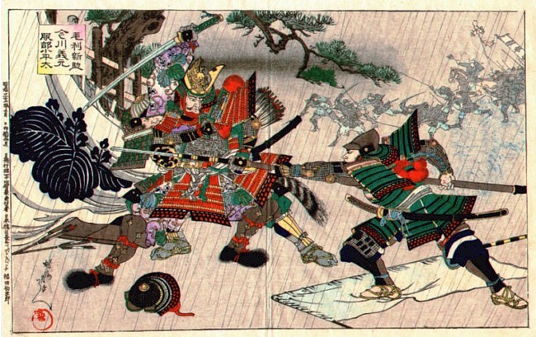
Feudal Japan (Kamakura Period)
The period back when the samurai and shinobi fought to gain control of Japan.
The period is known for the emergence of the samurai, the warrior caste, and for the establishment of feudalism in Japan. The Kamakura period ended in 1333 AD, with the destruction of the shogunate and the short reestablishment of imperial rule, under Emperor Go-Daigo byAshikaga Takauji, Nitta Yoshisada, and Kusunoki Masashige.

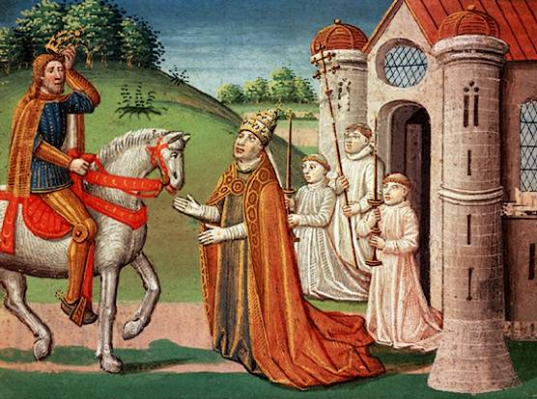
Middle Ages
Dungeons, dragons, knights and castles! Classical society broke down. Centralized government and law disintegrated, leading to the rise of feudalism, the rise of the Roman Church, The Inquisition, the Plague... What seems horrendous was actually the beginning of modern society. Learning did not perish. A majestic and dark period in history.

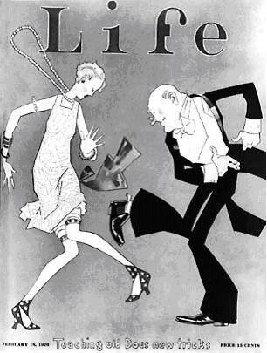
The Roaring 20's
The 1920s were generally a decade of empowerment. A war had just been ended; the troops had been dismissed. In New York, there was the Harlem Renaissance, and African Americans were having a chance to have voices in this world, to create art and have a community of art and inspiration surrounding them. Women everywhere in the US were starting to feel their power and know they could make an impact on the world. Women had just gotten their right to vote! Flappers are great in general--the clothing, the music, the Charleston! The 1920s were exciting! Prohibition was alive and well, with asymmetrical sometimes-villains: did you know Al Capone opened up a soup kitchen? People were having fun! This is a decade of great culture.

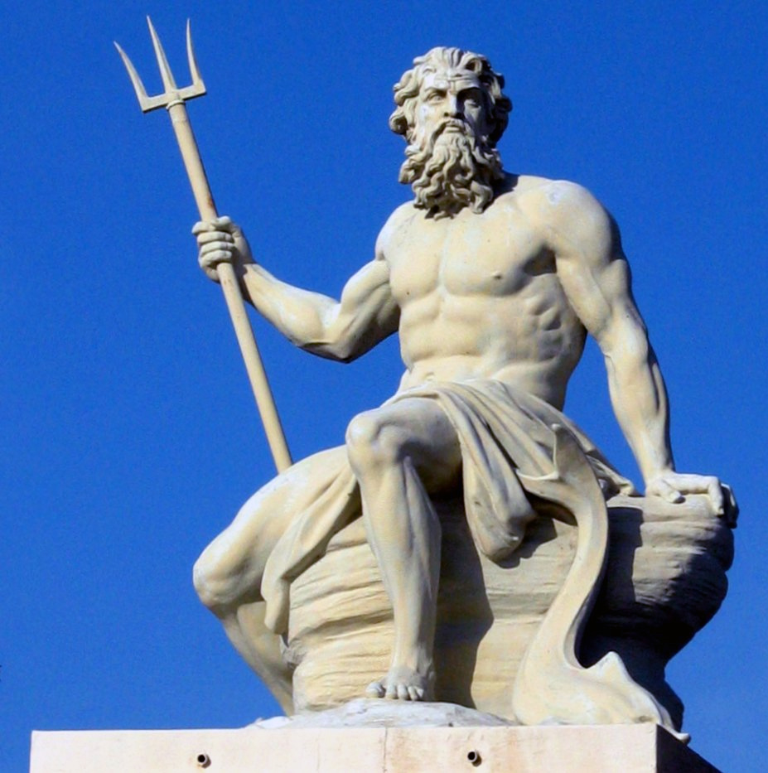
Ancient Greece/Rome
Ancient Greece and Rome were one of several classical periods of world history. Both provided substantial logic such as those of Socrates, Aristotle, Plato, Democritus, etc. Such vast amounts of knowledge and social organization booming during this period! ...it's like stepping into a whole new world. Gladiators, powerful Gods, heroes and myth were amongst most of the artwork and culture.

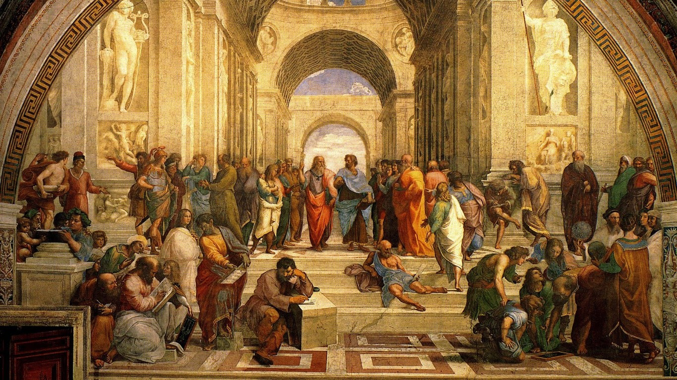
Renaissance
It originated in the 1500s-the 1600s in Italy. This ended the dark ages of the middle ages. It started the beginning to the end of religious tyranny. It was the birth of reason and enlightenment. Famous artist include, Leonardo Da’vinci, Raphael, and Michelangelo.

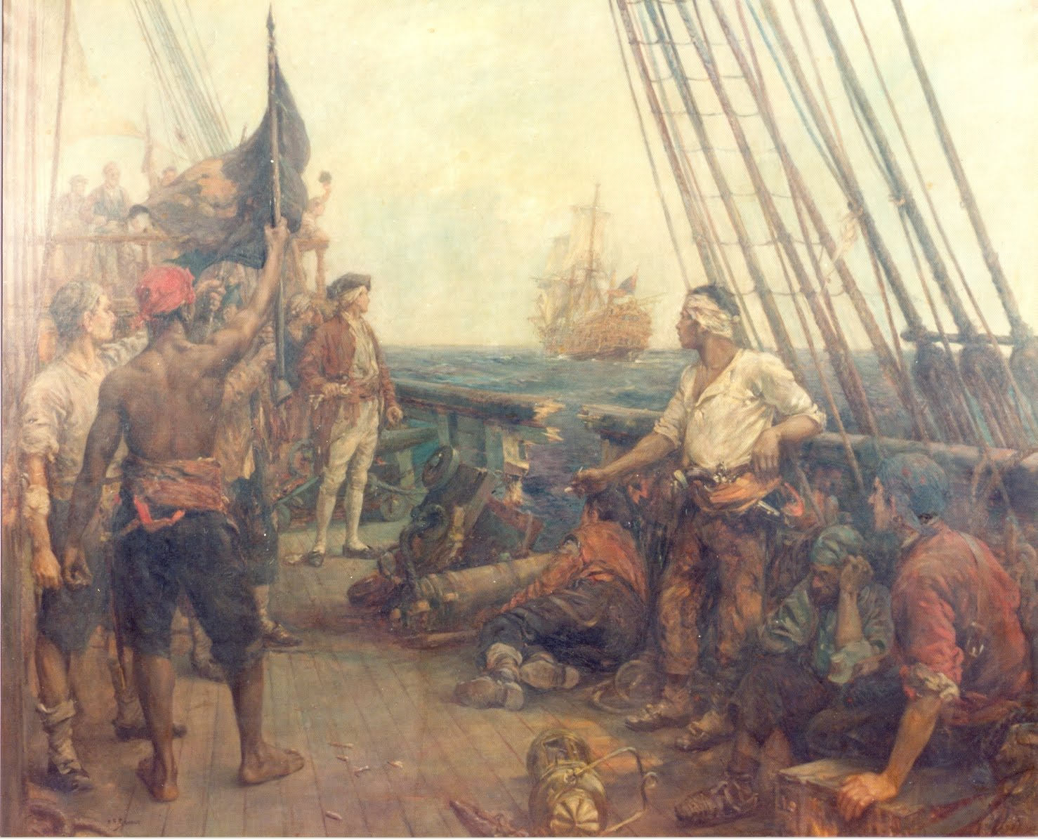
Golden Age of Piracy
Cutthroats, naval warfare, treacherous waters, unexplored islands, riches, and adventure... Piracy arose out of, and mirrored on a smaller scale, the conflicts over trade and colonization among the rival European powers of the time, including the empires of Britain, Spain, the Netherlands, Portugal and France. Most of these pirates were of English, Dutch and French origin..

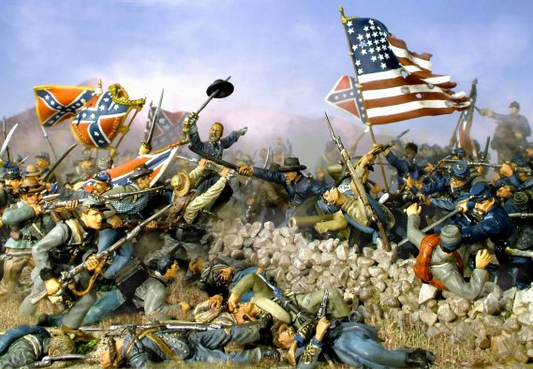
American Civil War
The most important reason the Civil War was fought was to preserve the union, but the undisputed cause of it was slavery. The South left the union when Lincoln was elected because of his stance that slavery could not be allowed to spread to new territories. Note that slavery caused the war but preserving the union was the primary objective. Evidence to this is the fact that Lincoln did not emancipate the slaves in the union free States until the war was won because he wanted to keep them in the union.There was also significant abolitionist movements at the time mostly among the northern blacks, woman, and Quakers.

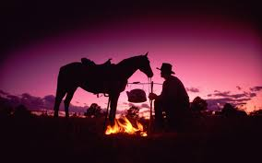
Wild West
Cowboy outfits and riding on a horse across the hot Arizona desert
Gunslingers, sharpshooters, treasure, wild life. Smells of adventure
Because crossing the American desert is so awesome, especially wearing a Poncho with two pistols.
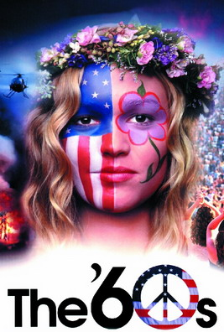

The Sixties
All authority was defied and millions of young Americans thought they could change the world--either through music, drugs, and universal love or by "putting their bodies on the line" against injustice and war.


The Future
The future. Your future? Earth’s future? So many possibilities out there that we have yet to discover... and as a bonus, it never ends!

