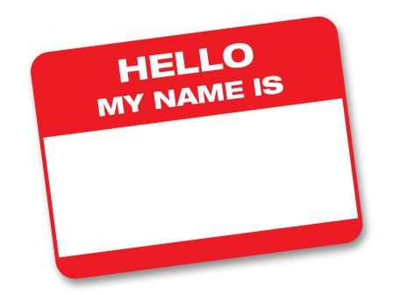
What about your name?

Full Name:______________________________

- What do you know about your first or last name? Is there a story behind it?

- How do you feel about your name and why? Be specific.

- If you could change your first or last name, would you? Why or why not?

- Do you have a nickname? If so, what is it? Why do you have this nickname?

