**PRESS HARD WITH COLOR PENCIL, MAKE SATURATION (BOLD COLOR)**

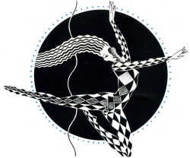

Color in the triangle. Then overlap with **black**

Color in the triangle. Then overlap with **white**

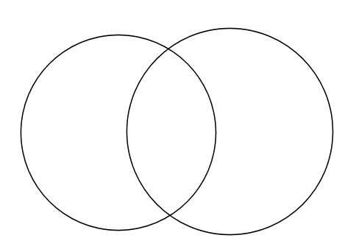

Choose 2 **complimentary colors** (opposite of the color wheel). Draw one color in each circle and overlap in the middle.

Choose 2 colors you will use in your final pop art drawing. Draw one color in each circle and overlap in the middle.

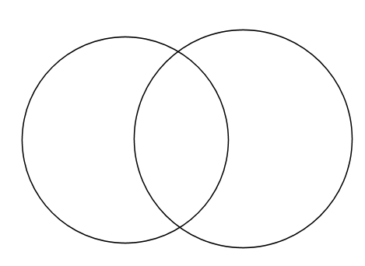

Heavily saturate box with **yellow**

Heavily saturate box with **blue**

Heavily saturate with box with **red**

Choose a color and shade in shape from **dark to light**